- THE TITLE OF THE PROJECT
Problems of Mathematics Education: A search for its reasons in Aliyah Madrasahs of Dhaka City.
- STATEMENT OF THE PROBLEM
In Bangladesh on the field of madrasah education few researches had been done. And in the Institute of Education and Research (IER), University of Dhaka being the highest seat of learning in the arena of Education in Bangladesh three or four studies have been conducted on madrasah related issue. As grade-X is one of the important periods for someone’s education career so the main aim of the study is to identifying the problems of mathematics education at grade-X of Aliyah Madrasahs in Dhaka city. I will conduct my research on the basis of four main points, those are methods and content, environment and classroom management, student and teacher related issues.
Skills and attitude towards mathematics is important for their upcoming life and professional career. To my knowledge, no research has been done to find the problems of mathematics in Aliyah madrasahs. A huge number of students are studying at madrasahs and it is 2200927 in 2010 (BANBEIS, 2011). Madrasahs occupy an important place in the educational and religious system of Bangladesh. Around 19% (The Financial Express, August11, 2010) of the total secondary level students are at registered Aliyah madrasah. There are over 13,000 government-registered Madrasahs at the primary, secondary and higher levels and quite a few thousands unregistered ones (Choudhury, 2007). However, here is a lot of controversy in the madrasah education related issues. The findings of the research might have some significance for the future such as special initiative/project to develop the mathematics skills of madrasah students. This study will be conducted at the aim for informing policy makers, teachers, teacher educators, curriculum developers, research students and other stakeholders that what the problems of mathematics education in Aliyah Madrasahs are.
There is a common concept about madrasah students is that they are burden of the society and about madrasah education system is that it not up to the mark (Ali, 2005). That is why some of the people have a negative thinking about madrasah education system and its impact straight goes to the madrasah students. This scenario led to my interest to find out that where are the problems regarding mathematics education in madrasahs.

- OVERVIEW OF LITERATURE
The objective of mathematics education is teaching of practical mathematics (arithmetic, elementary algebra, plane and solid geometry, trigonometry) to most pupils (Wikipedia, 2011).
Country director of the WB Dhaka office Ms. Ellen Goldstein said: "Learning outcomes for English and Mathematics were lower in registered madrasahs than in regular schools"(The Financial Express, August11, 2010, last page). The WB survey said almost all of the top scorers in English come from schools, while Aliyah madrasah students are grossly under-represented in the top tier.
The study shows that the students at madrasahs score lower in mathematics tests compared to the students of publicly funded non-government schools.
Different types of interventions led to improvements in the mathematics achievement of students experiencing mathematics difficulty, including the following: (a) providing teachers and students with data on student performance; (b) using peers as tutors or instructional
guides; (c) providing clear, specific feedback to parents on their children's mathematics success; and (d) using principles of explicit instruction in teaching math concepts and procedures (Baker, 2002, abstract).
Abraham (2000) found that students are not involved in any creative or innovative activity in the class. In most of the cases memorization is found to emphasize. Teachers are seen to dominate solving problems in the whole lesson.
Textbook dependency is one of barriers of effective teaching. Kaikobad (2010) said that “there is lack of standard mathematics textbook what we need”. According to Abraham (2000) found that teachers insist that the type of question is different from the one which pupils encounter in a usual lesson or examination. It is, however, not true that pupils‟ performance would be better in solving the usual type of questions.
Teaching to test is one of the main problems of our country. „Teaching to the Test‟ might be called preparation for examination (Gipps, C.V., 1995, Pg-45). But if we look deep inside about this matter then we can find many other things to analyze. Teaching to the test means practice on items similar to those which are going to be tested may in some circumstances be a useful form of instruction (Linn & Gronlund, 2000). The main objective of teaching is to be teaching the students about any lessons desirable level according to the students‟ class. The teaching will be fruitful if the skills thus taught and practiced are transferable to other environments/situations. Close match of teaching and testing destroys the measurement value of the test. Test scores may be attractive but students may not truly understand the major concepts of the lesson. Teaching to the test activities emphasize total memorization and exclude creative and abstract-thinking skills. The practice also reduces the validity of standardized tests, and can create an incorrect profile of a student or madrasahs achievement. To test whether a pupil can apply skills and knowledge, s/he must be given a new problem to solve, or must be asked about the concepts in a different context. Our main objective of learning is the evaluation of what is a student learned. “Usually teachers are preoccupied so much in textbook teaching, and also influenced by examination Abraham (2000)”.
According to wiki answer I found some of the problems of mathematics which are given below by using summarizing procedure.
Math is sequential subject in nature. Children learn one math skill, which then enables another skill. Students who have not mastered a preceding skill have difficulty in learning new work. If a student is struggling in math, he needs a one-on-one diagnosis. Find a tutor who can observe a child to see where he or she gets lost in the mathematical process. For example, often in algebra, the problem is not the algebraic equation; the problem is a weakness in basic arithmetic. Once a tutor can narrow down the gaps in learning, a child’s math skills and self-esteem can be rebuilt.
Mathematics is an exact subject. All the other school subjects are not as exact. Many students have trouble with the exactness of math.
There is a shortage of math teachers. Another problem is that Math teachers have a sale-able well paying skill so that many of them go into better paying jobs than teaching.
Mathematics is believed to be the key for all other subjects but it is surprising that most students fail in it and yet pass other subjects. As mathematics is the root of knowledge tree (Ali & Ahmed, 2000) so I believe there is no work that someone can do without applying mathematics. Naturally students only fail the class room mathematics but they have often applied mathematics in their daily lives to solve problems. According to wiki answer the followings are some of the reasons that students fail in mathematics:
1. Negative attitude towards mathematics.
2. Fear due to pressure from friends that mathematics is hard. Failure of the teachers to give proper and simple explanation of mathematical terms.
3. Limited or even lack of learning materials.
4. Lack of enough practice by the students.
Nahid (2010) said that, mathematics education became limited at passing examination. Sometimes students memorize their mathematics lesson. There is no emphasis on teaching at classroom. There are number of good quality teachers but they are not teaching their lesson at the class time. They insist their students to come in their home for learning in private batch.
It is an unfortunate outcome of modern society that most of those who teach mathematics have never used mathematics outside of the academic environment. Hakim (2010) said that “teacher evaluation system is not practiced in Bangladesh”.
A teacher has to face in different challenges at mathematics teaching. Mathematical knowledge therefore acquires importance not for its own sake but for what it can deliver. Success in school mathematics has little to do with the classroom or with the child’s interests or motivation. Its importance within the academic context is totally out of proportion to either its applicability in the real world, its ability to provide a knowledge base for scientific and technological understanding at more advanced levels of learning, or to the broad cognitive skills it is often claimed to foster.
Teachers are trapped in stereo-type, and what they consider sometimes does not reflect the reality. In order to avoid this trap, we have to look at the reality again through critical view.
The methods and techniques used in any particular context are largely determined by the objectives that the relevant educational system is trying to achieve. According to Curriculum of Institute of Education and Research and Wikipedia methods and techniques of teaching mathematics include the following:
- Heuristic Method
- Laboratory Method
- Problem Solving Method
- Project Method
- Assignment Method
- Conventional approach
- Rote learning
- Exercises

According to Abraham (2000) Students of mathematics have to juggle with at least three mathematical languages: rhetoric, symbolic and graphical. Each of these languages has distinct characteristics and can be used in different ways to support, or to alienate, sense-making. So it is a challenge factor to deliver mathematical lesson to all level of students maintaining mathematical language.
Iqbal (2010) said that lack of good quality education book is a problem of mathematics education. In rural area mathematics education is hampered for a good mathematics teacher. Our students are creative in mind but the existing memorizing methodology destroying the confidence of our students. Mathematics is taught in Bangladesh without giving any logic or reasoning. That’s why students have anxiety about mathematics education.

- THE CONCEPTUAL FRAMEWORK
4.1 Description of Framework
A conceptual framework is shown below on the basis of main four points/variables. Those are methods and content, environment and classroom management, student-teacher related problems.
I also fix some indicators based on those main points/variables. At the time of tools, checklist and guideline development and during data collection I will keep those indicators in my mind.
4.2 Diagram
A diagram of conceptual framework is shown below:

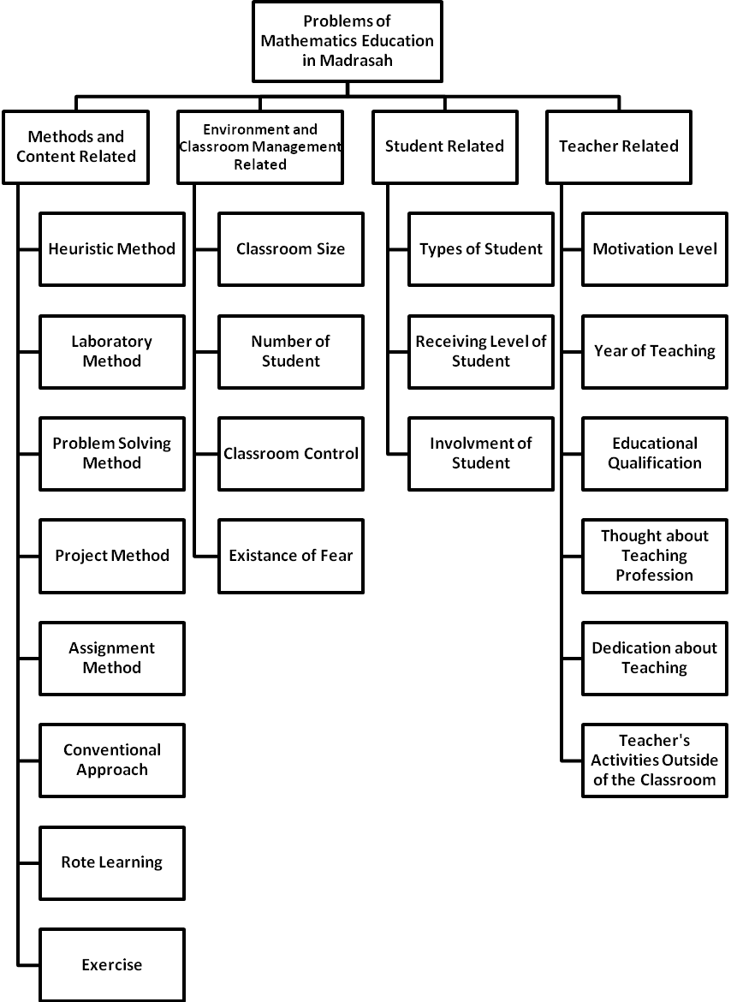
Figure-1: Diagram of Conceptual Framework

- RESEARCH QUESTIONS
To achieve this goal following research questions will be addressed-
1. What kind of teaching methods and classroom management strategies are used in mathematics teaching learning process?
2. Are the teachers’ adequately skilled and knowledgeable to teach mathematics effectively in the classroom?
3. To what extent the teacher’s are serious and sincere for mathematics teaching?
4. What are the problems that students and teachers are facing in the mathematics teaching learning process?

- COVERAGE
- Universe of Study
There are 70 Aliyah madrasahs in Dhaka city (BANBIES, 2011). All the students of grade-X of Aliyah madrasahs of Dhaka city are the main population of this study.
- Sampling Frame
In order to ensure the feasibility of the study, only 08 (eight) madrasahs from Dhaka city will be selected as study sample. These madrasahs will be selected after categorizing the population into three strata according to the results of their last year public examination (Dakhil):
- Madrasahs with good results in Dakhil examination/Category-A: 2 Madrasahs (Codes: A1 and A2)
- Madrasahs with moderate results in Dakhil examination/Category-B: 4 Madrasahs (Codes:B1, B2, B3 and B4)
- Madrasahs with poor results in Dakhil examination/Category-C: 2 Madrasahs (Codes: C1 and C2)
- Sampling Procedure
Above mentioned categories will be identified with the help of Bangladesh Bureau of Educational Information and Statistics (BANBEIS).
Teacher Sampling Procedure
Eight-ten mathematics teachers will be selected from each madrasah for the FGD of Mathematics teacher. If any madrasah contain more than one mathematics teacher then most experienced one will be selected. I will try to ensure gender parity if available/possible.
Student Sampling Procedure
For FGD
Three FGDs will be arranged (one FGD from each category) and each group will have 8-10 students. Students will be selected by following systematic random sampling.
For In-depth Interviews
The process of selecting my research participant was followed purposeful sampling system. Some qualities which will be followed to be selected as my research participant are mentioned below-
- Willingness to share
- Analytical mind
- Reliable
- Good communicative skill
- Capability of share (information rich participant)
- Courage to say negative aspect of their own problems
- Recommendation from teachers to be a research participant.

- Units of Observation and Sampling Size
Table-1: Class Observation Plan
Name of the Madrasah | No of Classes to be Observed
Category A-1 | 2 Classes
Category A-2 | 2 Classes
Category B-1 | 2 Classes
Category B-2 | 2 Classes
Category B-3 | 2 Classes
Category B-4 | 2 Classes
Category C-1 | 2 Classes
Category C-2 | 2 Classes
Total | 16 Classes
*Classroom observation checklist and field note approach will be used at the time of classroom observation

Sampling Size
- 4 FGDs (one with mathematics teacher and three with students of three categories)
- 3 In-depth Interviews with mathematics teachers (one from each category)
- 6 In-depth Interviews with students (2 students from each category) 3 boys and 3 girls, if possible
- 16 (2 classes from each madrasahs) mathematics classroom observation

- DATA COLLECTION
7.1 Tools of Data Collection
Non-Participant Observation:
An observation checklist will be developed to collect data related to the problems of mathematics in the classrooms of madrasahs. Quantitative and qualitative data will be collected through observation. Observation was done with a combination of two separate parts; a) quantitative part: checklist and numerical data, and b) qualitative part: descriptive data using field note approach.
In-depth Interview:
In-depth interviews will be conducted to collect in-detail data. Three mathematics teachers will be selected as a sample for in-depth interview from three different categories A, B and C. Two students (a boy and a girl, if possible) will also be selected from each of the above mentioned categories. In-depth interviews will be conducted with the help of a guideline.
FGD (Focused Group Discussion)
FGDs will be conducted with the mathematics teachers and students to collect data from the group perspective. The main focus of the FGDs will be to find out teachers’ and students’ opinion about the problems of mathematics in their madrasah. A total of 04 (four) FGDs will be arranged to acquire the in-depth information. One FGD will be conducted with mathematics teacher from each madrasah and another three FGDs will be with students from three different categories.
7.2 Data Collection Process
Total data collection process will be conducted with the overall supervision of Research Supervisor, Mr. Shah Shamim Ahmed, Chairman, Department of Educational Evaluation and Research, Institute of Education and Research, University of Dhaka. I will go to every madrasah along with the formal consent letter to conduct research on their madrasah. A Research Assistant will be recruited to help at the time of data collection. Field note approach will be used at the time of observation and mobile recorder along with backup main theme data gathering procedure will be followed.
- DATA PROCESSING
Data will be analyzed in two ways: a) descriptive analysis will be made for qualitative data, and b) quantitative analysis will be employed for numerical data.
In qualitative analysis, the data will be interpreted based on the themes emerged from the data collected through qualitative modes. Basically, I will follow the thematic analysis procedure. In quantitative analysis, simple statistical such as frequency distribution, percentage etc. will be computed to explore the general situation in the madrasahs. Statistical tests will also be employed to find out the significance where necessary.
- TIME BUDGETING
The work schedule of the proposed activities is presented below:
Table-2: Work Plan for Proposed Activities
Activities | Months
Activities | 1st Month |  |  |  | 2nd Month |  |  |  | 3rd Month |  |  |  | 4th Month
Detail literature review
Tools Preparation
Recruitment of a data collector
Training of data collectors
Piloting of the total process in a madrasah
Sample selection
Data collection
Data processing and analysis
Preparation of draft report
Submission of final report

- INTRODUCTION OF SUPERVISOR
Shah Shamim Ahmed
Chairman, Department of Educational Evaluation and Research (EER)
Institute of Education and Research (IER), University of Dhaka
ssahmed.ier@du.ac.bd, ssahmedier@yahoo.com
+88 01552 333 306

- COST ESTIMATION
Table-3: Budget of the Study
Purpose | Person/Time | Rate | Total
A. Honorarium
Honorarium of Researcher | 4 Months | 2,500 | 10,000
Honorarium of Research Assistant | 3 Months | 2,000 | 6,000
Sub Total of Honorarium | 16,000
B. FGD and Interview Costs
FGD participant entertainment cost | 10 | 150 | 1,500
Sub total cost for one FGD |  |  | 1,500
Total number of FGD |  |  | 4
Total Cost of FGD | 6,000
Honorarium of in-depth interview participants | 9 | 300 | 2,700
Sub total cost of FGD and Interview | 8,700
C. TA/DA
Researcher |  |  | 5,000
Research Assistant |  |  | 5,000
Sub Total cost of TA/DA | 10,000
D. Other Costs
Stationeries |  |  | 2,000
Communication cost- Mobile, Internet card etc. |  |  | 1,500
Tools Photo copy and Report Printing and others |  |  | 3,800
Miscellaneous |  |  | 2,000
Sub Total of Other Costs | 9,300
Grand Total = (A+B+C+D) | 44,000
In Words: Forty Four Thousand Taka Only
12. REFERENCE

Abraham, A. (2000). Education challenges-focus on effectiveness, http://www.eduplace.com/rdg/res/vogt.html

Ahsan, S. (2007). Classroom Assessment Culture in Secondary Schools of Dhaka City:
‘Assessment of Learning’ or ‘Assessment for Learning’? Unpublished Research

Ali, M.E.(2005). Problems and Prospects of Madrasah Education in Bangladesh. World Spiritual Institute of New York, Under the State University of New York, USA.

Ali, P.M.A., & Ahmed, M.R.U. (2000). Gonit Shikkon, Secondary Education Development Project, DMHE

Asadullah, M. N., Chaudhury, N., &Josh, S. R. A. Z (March 15, 2009) Secondary
School Madrasahs in Bangladesh: Incidence, Quality, and Implications for Reform.
Draft Retrievedfrom http://siteresources.worldbank.org/BANGLADESHEXTN/Resources/295759-
1271081222839/6958908-1281045267820/MadrasaReportFinal.pdf

Baker,S., Gersten,R., & Lee, D.S.(2002). A Synthesis of Empirical Research on Teaching Mathematics on Low- Achieving Students. The Elementary School Journal 103(1), Abstract. www.jstor.org/pss/1002308.

Bangladesh Bureau of Educational Information and Statistics (BANBEIS). (2008) Retrived
January 25, 2011 http://www.banbeis.gov.bd/db_bb/madrasah_education_2.htm

Chowdhury, A.M.(2006). Dhaka. Banglapedia, National Encyclopedia of Bangladesh. Retrieved February 02, 2011, http://www.banglapedia.org/httpdocs/HT/D_0145.HTM Das, N.(2000). Ganit Shikkhon, Dhaka; Provati Library

FE Reports (2010, August11), WB finds quality of madrasah education lackadaisical. The Financial Express. Retrieved from http://www.thefinancialexpress-bd.com more.php news_id=108693

Gipps, C. V., (1995), Beyond Testing: Towards a Theory of Educational Assessment. London: The Felmer Press.

Goldstein, E. (2010, August 10). Country Director Speech. Retrieved from Online version of The Financial Express. http://www.thefinancialexpress-bd.com more.php news_id=108693

Linn, R.L., & Gronlund, N. E.(2000). Measurement and Assessment in Teaching. New Delhi: Pearson Education, inc.

Nahid, N.I., Iqbal, M. J., Hakim, A., & Kaikobad, M. (August 08, 2010) Ganit K Anondomoe Kore Tulte Hobe: Round Table Meeting, The Daily Prothom Alo.

Rahman, S., et al. (2006).Curriculum: Bachelor of Education (Honors). University of Dhaka: The Curriculum Committee, Institute of Education and Research.

Wikipedia, the free encyclopedia. (2011, January 10). Mathematics education Retrieved January 26, 2011 en.wikipedia.org/wiki/Mathematics_education

